**Chapter 3: Food Chains and Food Web**

* **Food chains**

**Classification Of Animals According To The Food They Eat**

**CARNIVORE HERBIVOURE OMNIVORE**

*Animals that eat the flesh and *Animals that eat plant only. *Animals that eat both  
 meat of other animals. *certain herbivores like to eat plant and other animals  
*They have sharp claws, sharp grass and leafy parts of young *Animals such as swan,  
 teeth and tear their flesh into *Some herbivores like to eat duck or chicken eat  
 pieces. juicy fruits or nuts worm, small insect or  
 *Certain carnivores feed on grain  
 insects *A bear eats honey and   
 fish

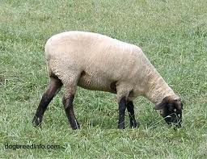

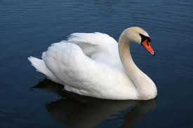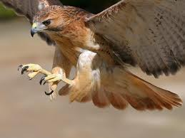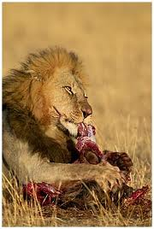

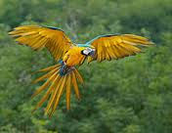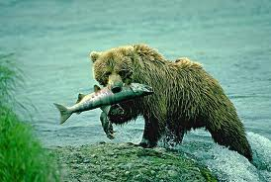

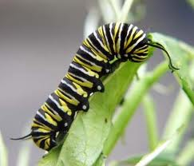

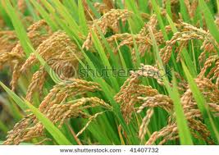 caterpillar  
 (primary consumer)

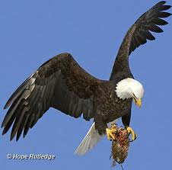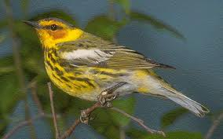 Paddy   
 Eagle (tertiary consumer)  
  
  
 Bird(secondary consumer)